72.02.02
To August Jochmus von Cotignola
Ferd. v. Müller, Jochmusiana B, 2, Handschriftenabteilung, Bayerische Staatsbibliothek, Munich.

Melbourne, im bot Garten
2/2/72.
Gerade noch vor dem Postschluss, edler Herr Marschall, ist es mir möglich Ihnen die Skizze eines grossen Landsees zu senden, dem ich Ihren berühmten Namen aufprägte, u durch welchen wir stets an Ihre Anwesenheit in Australien erinnert werden. Ich habe den ersten Geographen der Zeit, Hr Prof. Aug. von Petermann, eben auch mit dieser Entdeckung bekannt gemacht.
Ich glaube, dass der Feldmesser Birch, sich sehr geehrt fühlen würde durch einige anerkennende Worte u, darf ich es sagen, vielleicht ein kleines Souvenir.
Mit ehrendem Sinne u besonderer Ergebenheit der Ihre
Ferd. von Mueller

Melbourne Botanic Garden,
2 February 1872.

Just before the close of the mail, noble Marshal, I am able to send you the sketch of a large inland lake to which I attached your famous name, and which will always remind us of your visit to Australia. I have also just acquainted the foremost geographer of our time, Professor August von Petermann, with this discovery.
I believe that surveyor Birch would feel very honoured to receive a few words of acknowledgement and, may I add, perhaps a small souvenir.
With sentiments of respect and special devotion
Yours
Ferd. von Mueller.

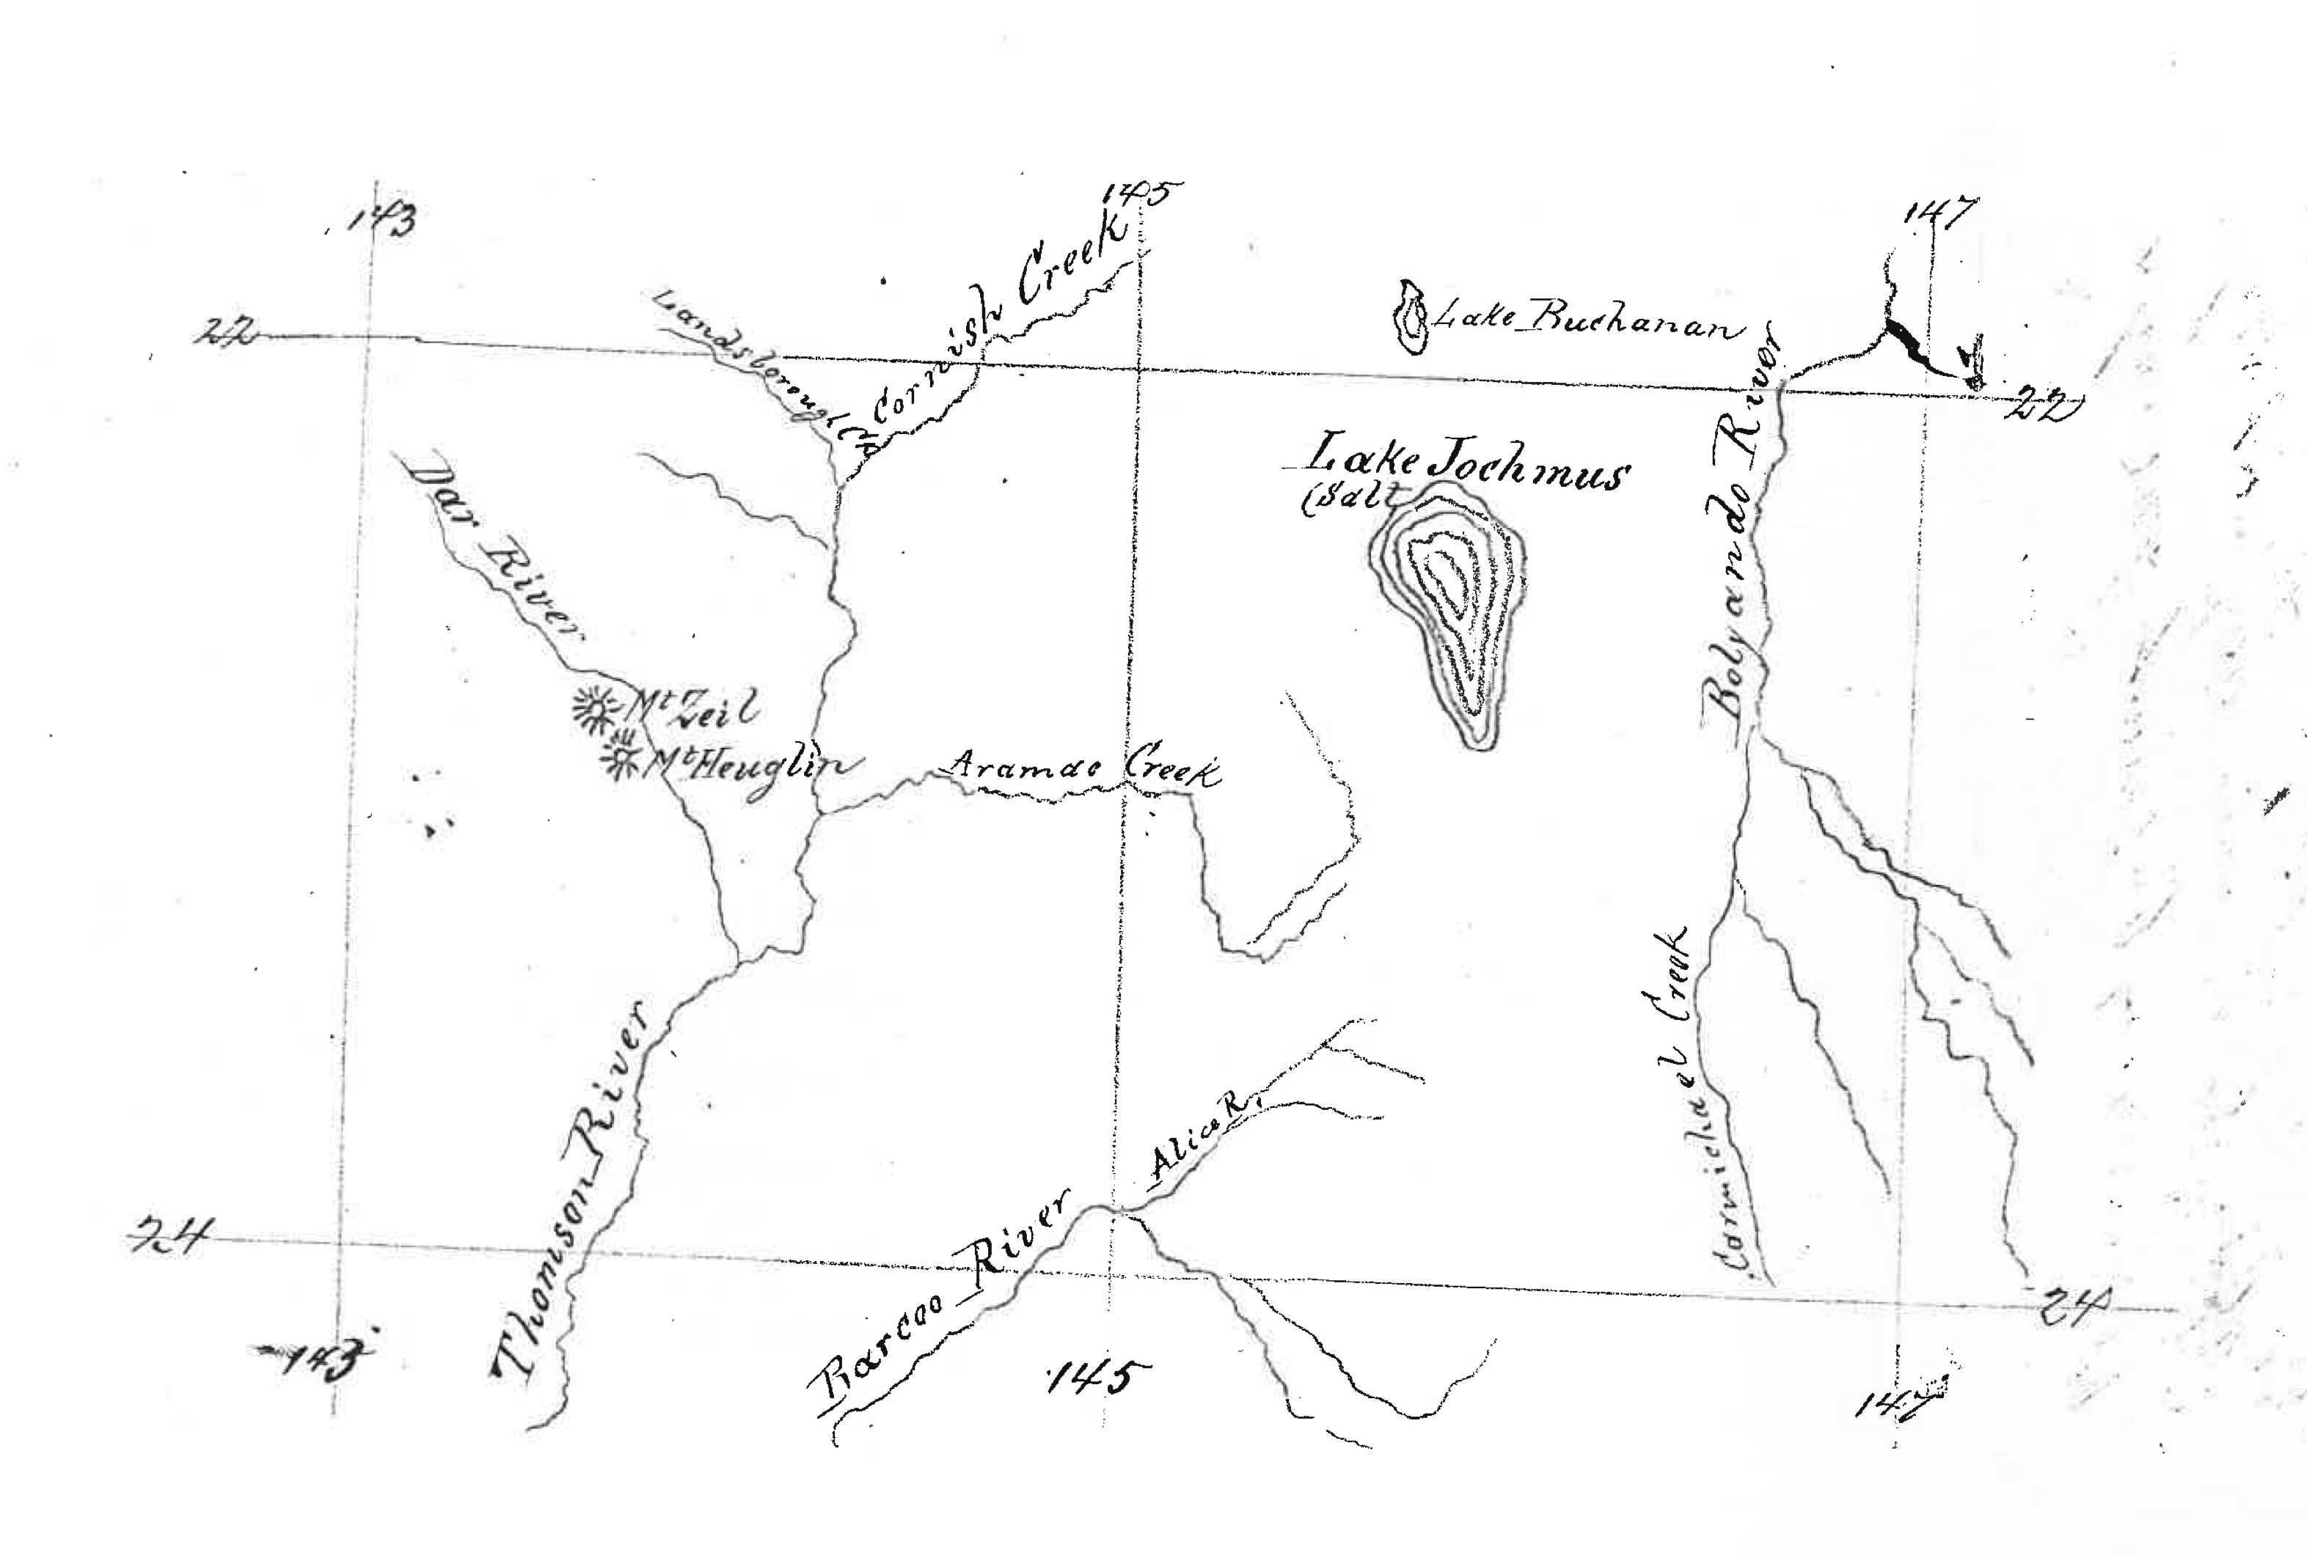

Published on-line at https://www.digitale-sammlungen.de/en/view/bsb00144323?page=,1.
The file includes a sketch map by the surveyor Charles Weldon Birch 72-02-02_image01.jpg This map shows the location of the lake Birch had discovered in central Qld and named ‘Lake Jochmus’ in accordance with M's request that he name a geographical feature in Jochmus's honour (see M to C. Birch, 10 November 1871 (in this edition as 71-11-10a)). Also marked on the map are 'Mt Zeil' and 'Mt Heuglin', names likewise almost certainly bestowed in response to a request from M. Birch's names for all three features were included on the map, 'Süd-ost Australien', issued with Petermann's geographische Mittheilungen, vol. 19, 1873, a digitized copy of which is available through the National Library of Australia, http://nla.gov.au/nla.obj-232433873. However, they do not survive on modern maps; 'Lake Jochmus' is now known as Lake Galilee, while the positions of the two 'mountains' correspond approximately to two low hills, now known as Prairie Peak and Mt Mitchell, about 25 km west of today's small town of Muttaburra, about 80 km north of Longreach.
Letter not found. With his letter M evidently sent Petermann Birch's account of his discovery of the lake, enabling Petermann to publish a German translation of this in Petermann's geographische Mittheilungen, vol. 19, 1873, p. 415; see C. Birch to M, January 1872 (in this edition as 72-01-00a). M also sent a copy of Birch's sketch map to Petermann; this is now in the archive in Gotha and was reproduced in Voigt (1996), p. 156 (where, however, it is mis-identified as Giles's map).

